### CS 340 Project Two: Grazioso Salvare Animal Shelter Dashboard

**Student Name:** Gabriela Pastor  
**Course:** CS 340 – Client/Server Development  
**Date:** December 21, 2024  
**Instructor:** Ruben Wilson

## Overview

This README file provides a step-by-step guide to completing the Animal Shelter Dashboard assignment. The project includes setting up MongoDB, managing animal data, creating CRUD functionality in Python, and developing a dynamic dashboard with interactive filtering options. The final dashboard displays rescue-related information, maps, and charts.

## 1. Accessing MongoDB Through the Terminal

### Prerequisites:

1. **Download and Install MongoDB**:
   * [MongoDB Community Edition](https://www.mongodb.com/try/download/community)
   * [MongoDB Compass](https://www.mongodb.com/products/compass) for GUI operations.
2. **Required Tools**:
   * Python 3.x
   * Jupyter Notebook (with required libraries installed).

### Steps to Access MongoDB:

1. Start MongoDB service:

bash

Copy code

sudo service mongod start

1. Connect to MongoDB:

bash

Copy code

mongo --host <host_name> --port <port_number>

1. Confirm connection status:

javascript

Copy code

db.runCommand({ connectionStatus: 1 })

## 2. Importing the AAC Database

### Task:

Import the Austin Animal Center (AAC) Outcomes dataset as the animals collection in the AAC database.

**Import and Execution**

**Task**: Import the AAC Outcomes CSV file into MongoDB using the mongoimport tool, specifying the database name as "AAC" and the collection name as "animals". Provide screenshots of the import command and its successful execution.

* *Output of the mongoimport command in the Linux terminal showing the command used to import the CSV file.*
* *Terminal output confirming successful data import, including the number of documents imported.*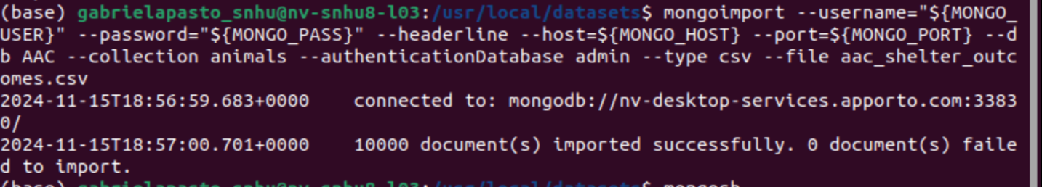
* 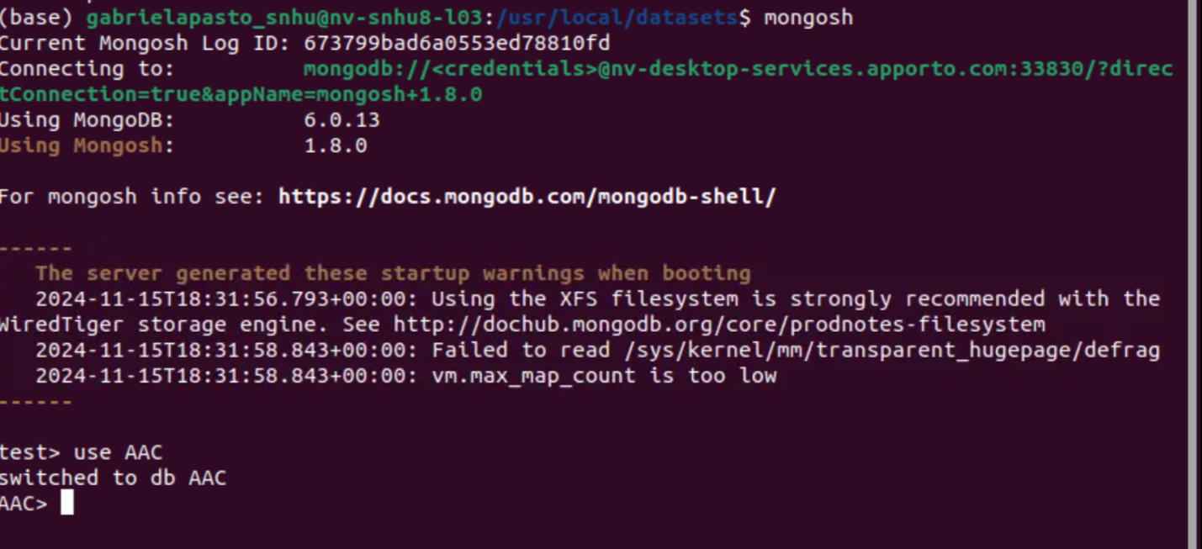

**3. Simple Index and Explain Function**

**Task**: Create a simple index on the key "breed" in the "animals" collection of the "AAC" database. Show an example query using this index and use the explain() function to verify that the index is being used. Provide screenshots of the index creation, the query, and the explain() output.

**Screenshots and Explanations**

* *Command in the mongo shell creating the simple index on "breed".*
* *Example query using the "breed" index (e.g., finding all animals with a specific breed).*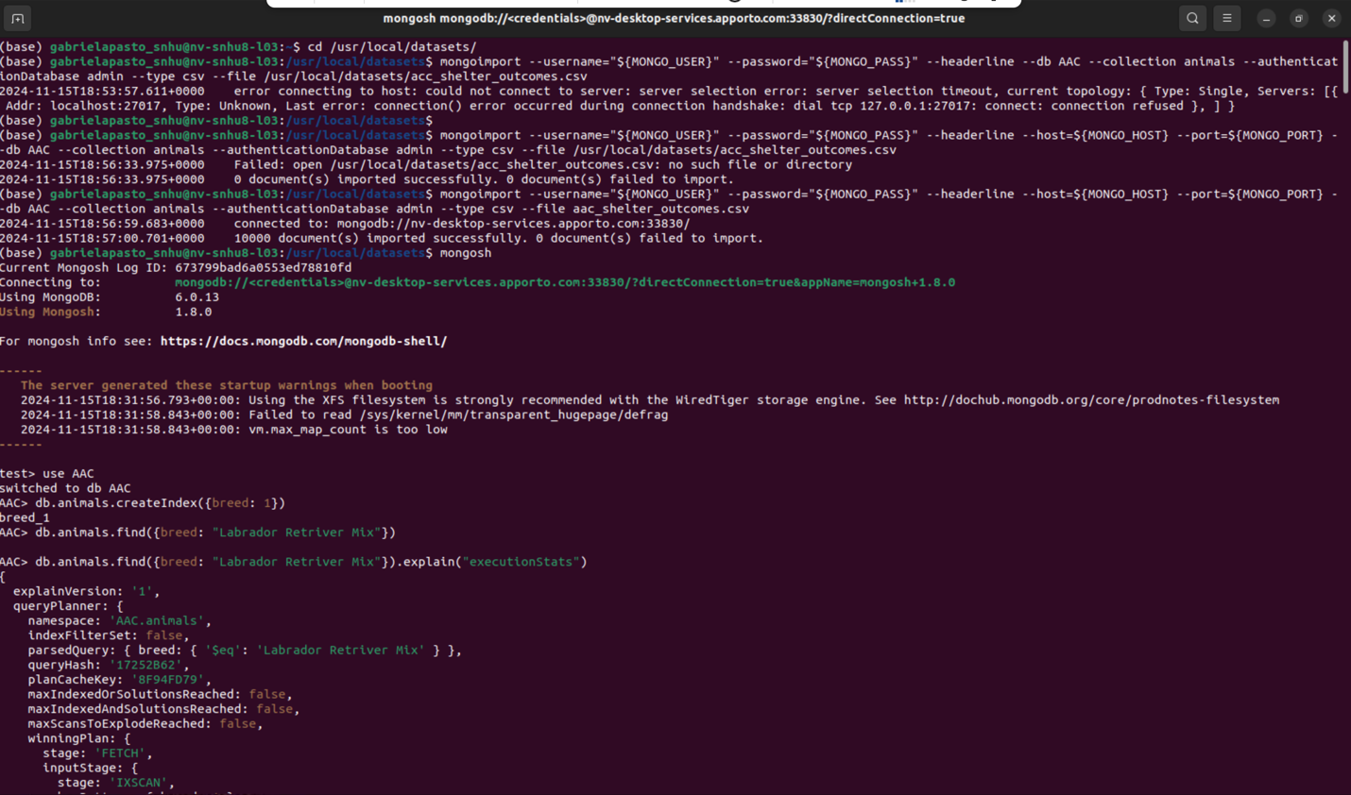
* *Output of the explain("executionStats") function showing that the index is used in the query execution plan.*

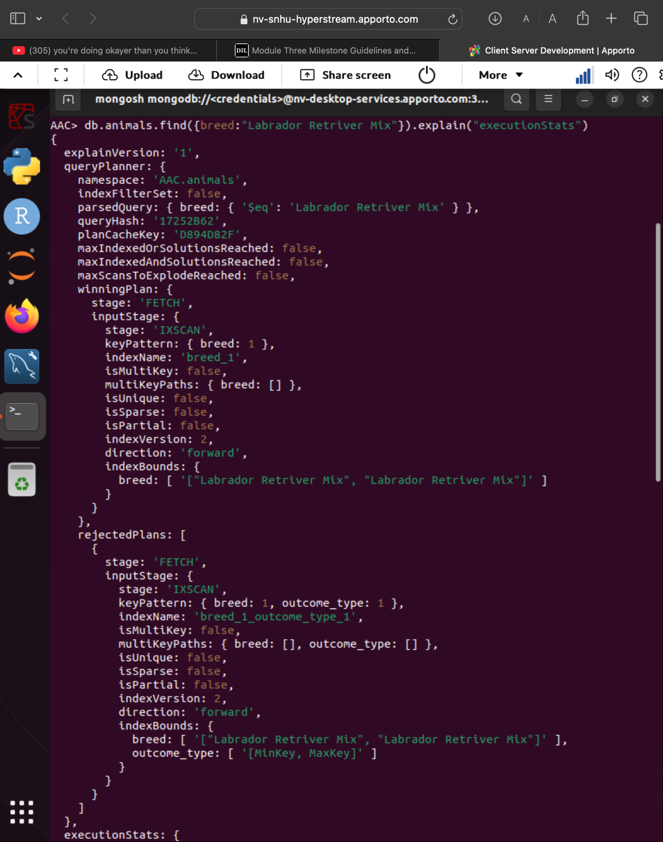

**4. Compound Index and Explain Function**

**Task**: Create a compound index on "breed" and "outcome_type" to improve the performance of queries looking for breeds with an "outcome_type" of "Transfer". Show an example query using this compound index and use the explain()function to confirm that the index is being used. Provide screenshots of the index creation, the query, and the explain()output.

**Screenshots and Explanations**

* *Command in the mongo shell creating the compound index on "breed" and "outcome_type".*
* *Example query using the compound index (e.g., finding all animals of a specific breed with an "outcome_type" of "Transfer").*
* 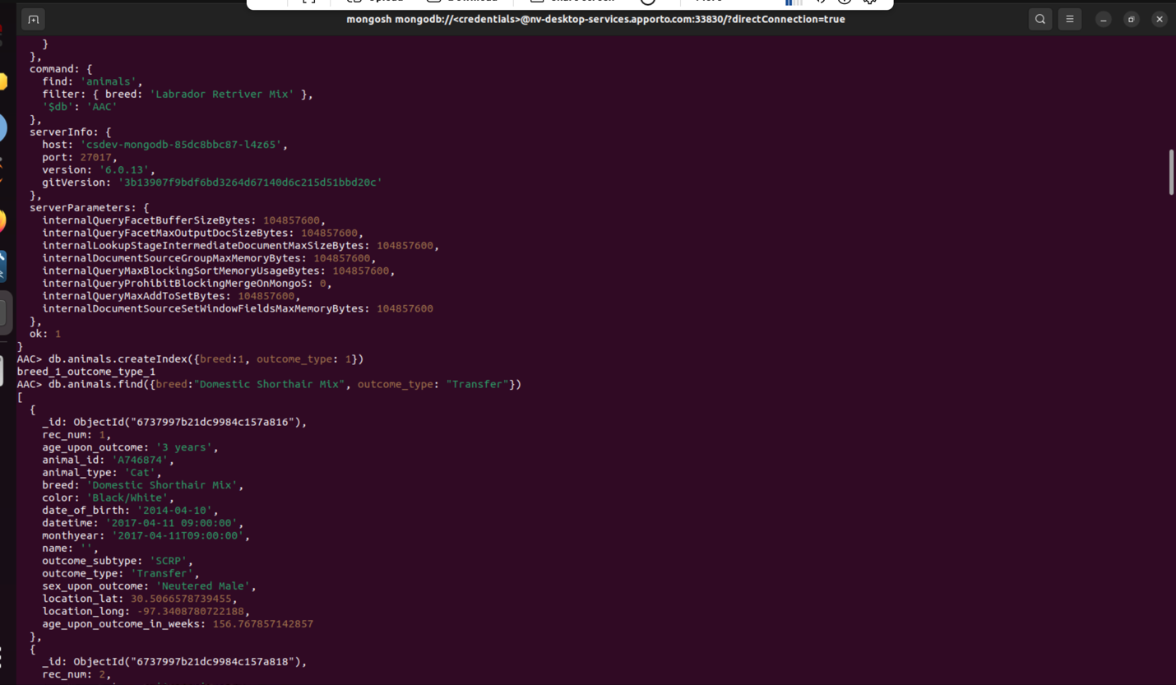
* *Output of the explain("executionStats") function showing that the compound index is used in the query execution plan.*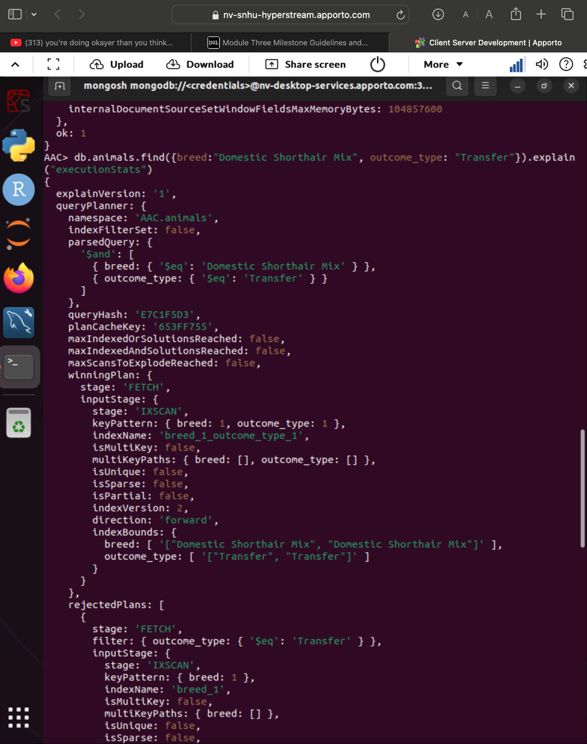

**5. Ensuring User Authentication**

**Task**: Create a new user account called "aacuser" for the "AAC" database with appropriate roles to ensure user authentication. Verify that both the admin and "aacuser" accounts can access MongoDB and list the databases. Use the db.runCommand({connectionStatus:1}) command to confirm the connection status for each user. Provide screenshots of the user creation and the login process for both accounts.

**Screenshots and Explanations**

* *Command in the mongo shell creating the "aacuser" account with the "readWrite" role on the "AAC" database.*

*db.createUser({ user: "aacuser",*

*pwd: "YourSecurePassword",*

*roles: [{ role: "readWrite", db: "AAC" }]*

*})*

* *Confirmation output showing successful creation of the "aacuser" account.*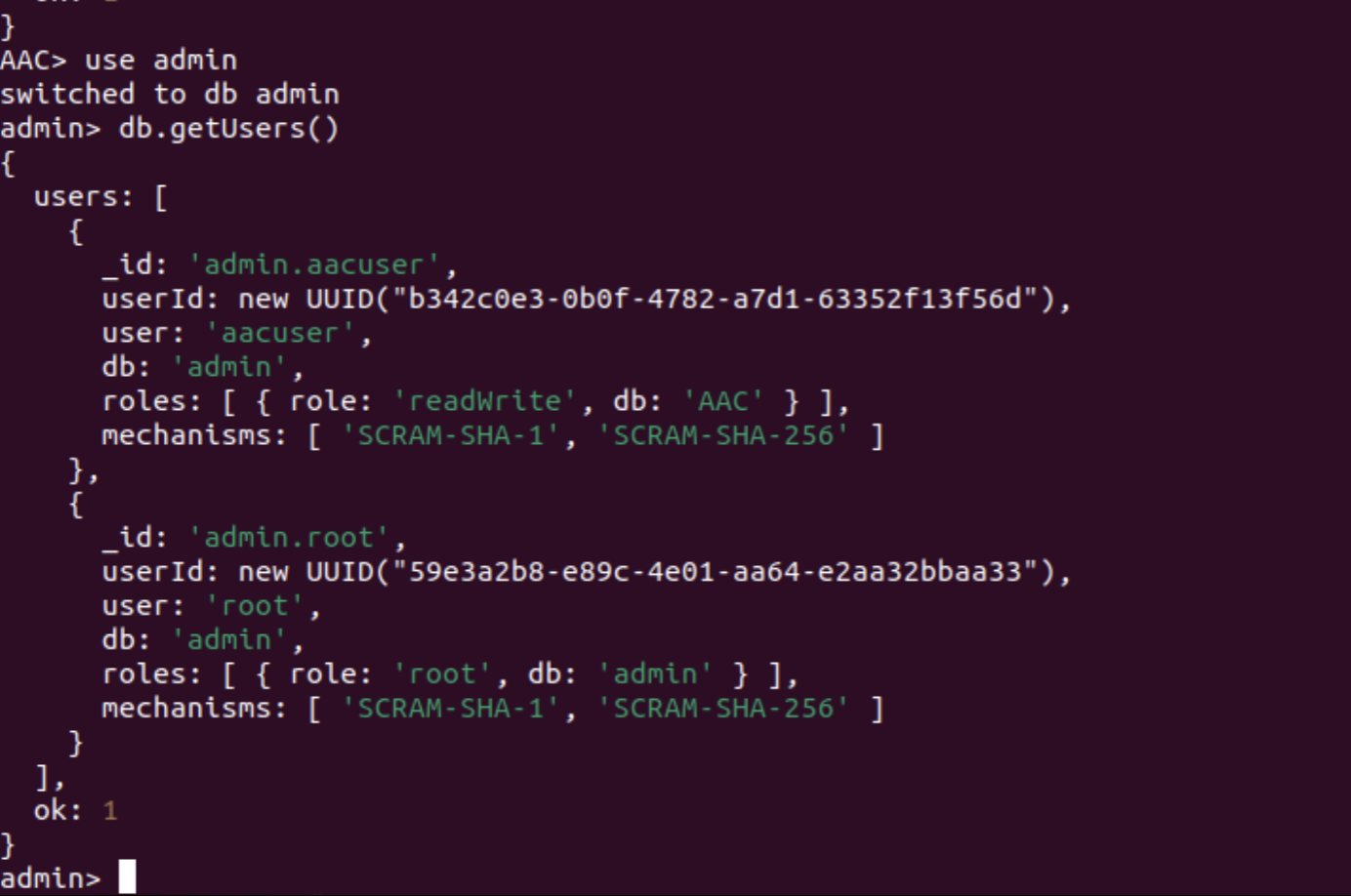
* *Logging into MongoDB as the admin user, including the login command and the output of db.runCommand({connectionStatus:1}) showing the admin user's connection status.*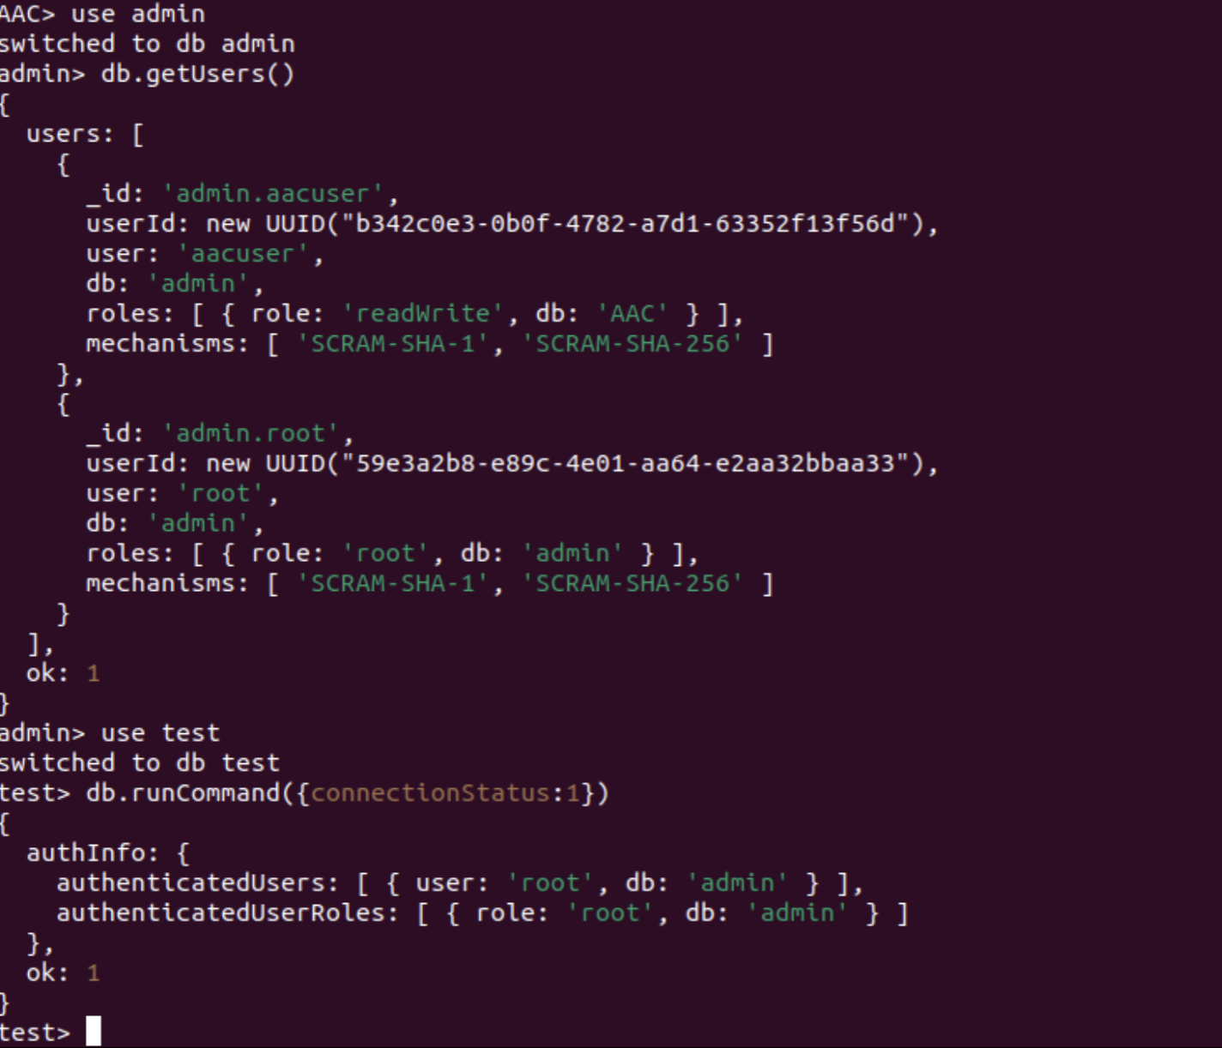
* *Logging into MongoDB as "aacuser", including the login command and the output of db.runCommand({connectionStatus:1}) showing the "aacuser" connection status.*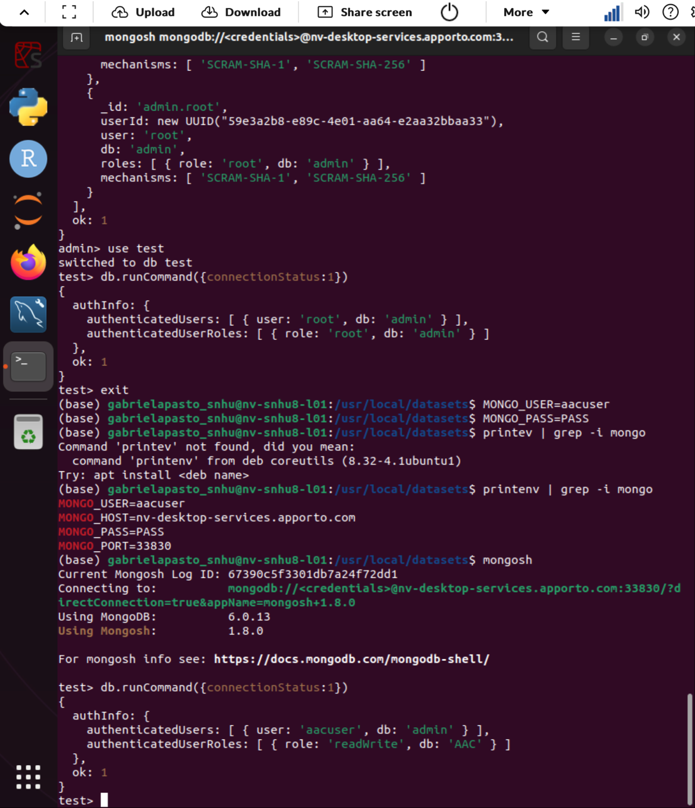

## Developing the Python Module for CRUD Operations: animal_shelter.py

**Task:**

**Development Process**

1. **Create Functionality**:
   * Validates input to ensure it is a dictionary.
   * Inserts the document and returns confirmation of success.
   * Challenge: Handling invalid data formats.
     + Solution: Implemented validation with Python's isinstance() function.

Create a Document

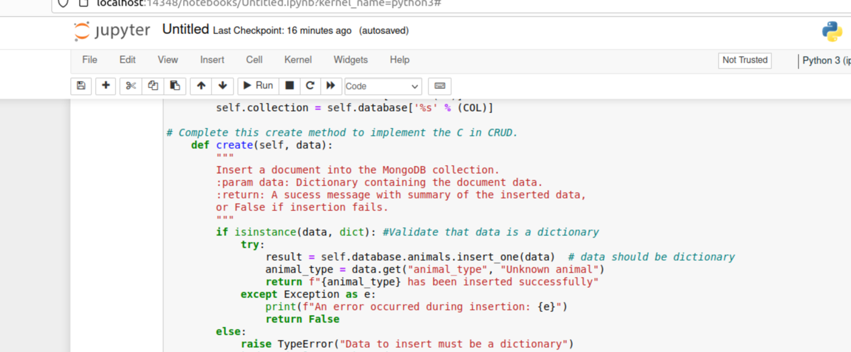

Output Screenshot

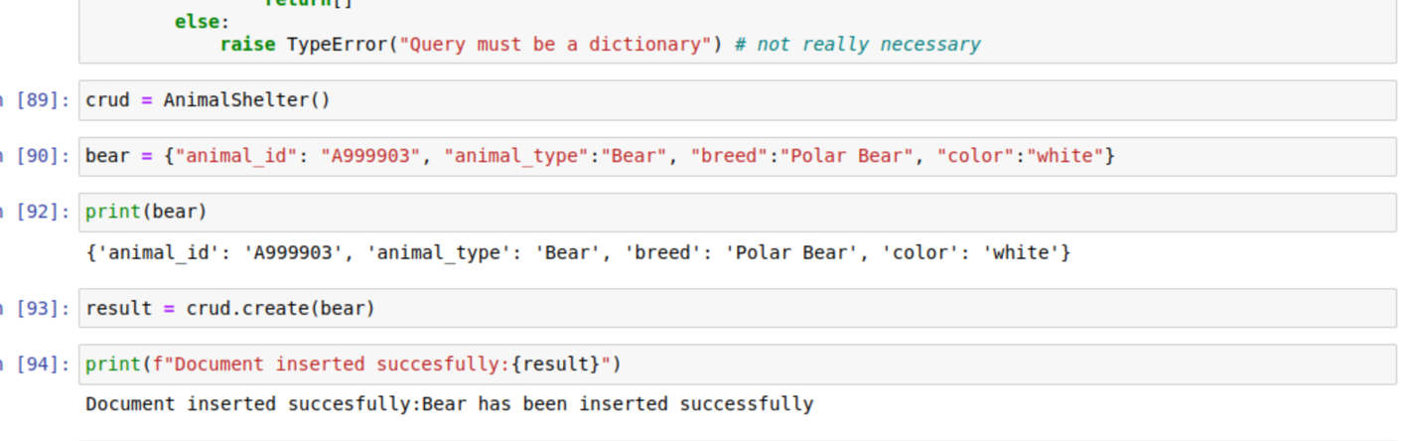

1. **Read Functionality**:
   * Accepts a query parameter and retrieves matching documents.
   * Formats the output using json.dumps() for better readability.
   * Challenge: Managing empty queries.
     + Solution: Returns an empty list and a message if no matches are found.

Query a Document

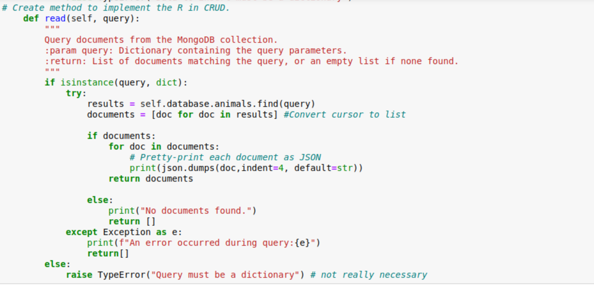Output Screenshot

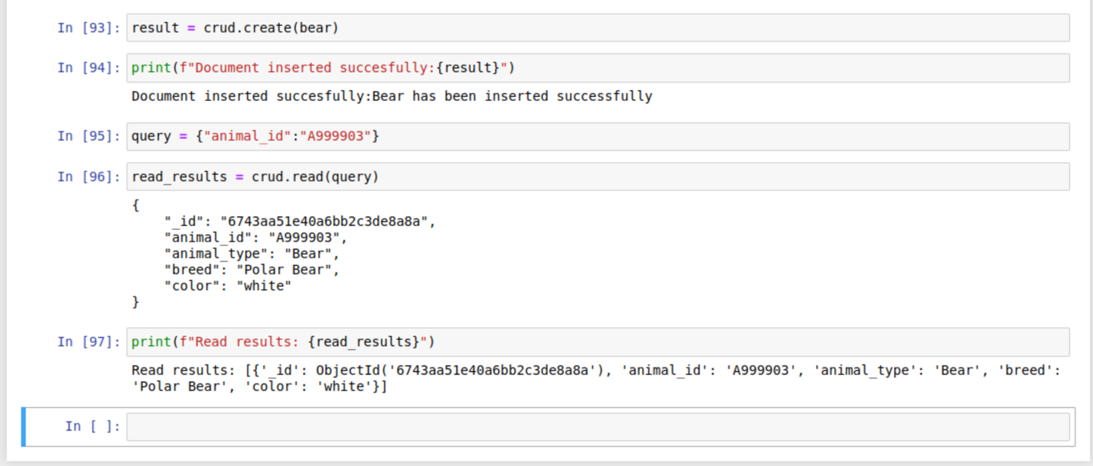

1. **Update Functionality**

* **Filters documents based on the query (e.g., animal_id).**
* **Modifies only the specified fields without affecting other data.**
* **Challenge: Preventing accidental updates to multiple documents.**
  + **Solution: Used update_one for targeted updates.**

Update a Document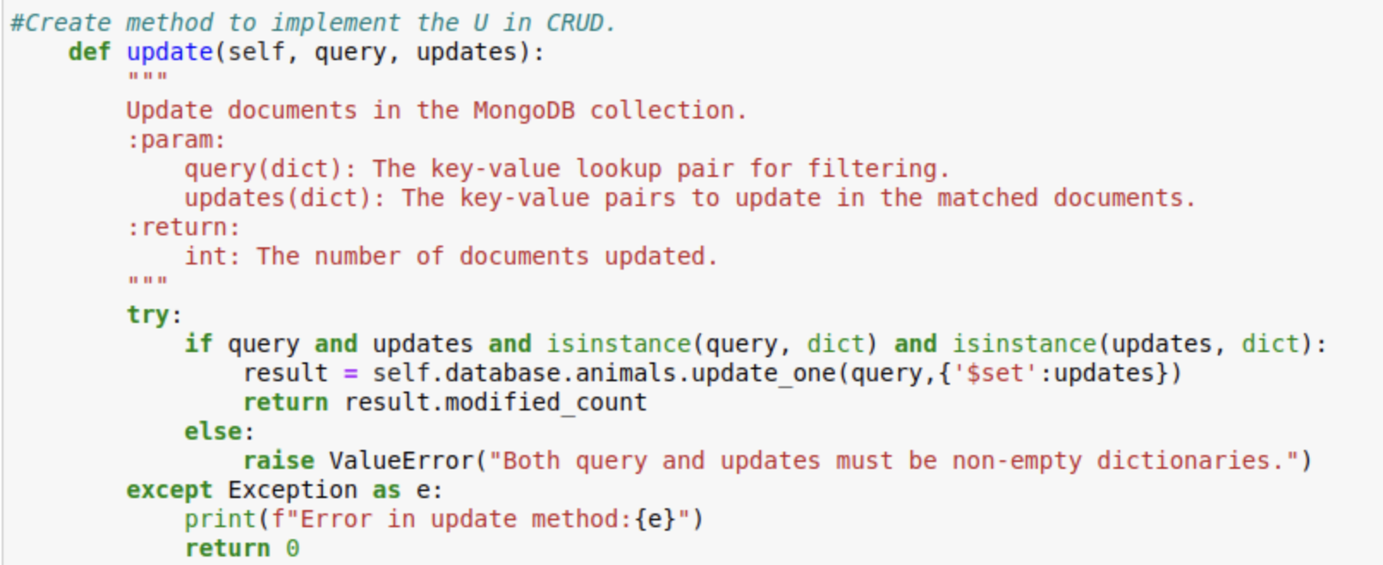

Output Screenshot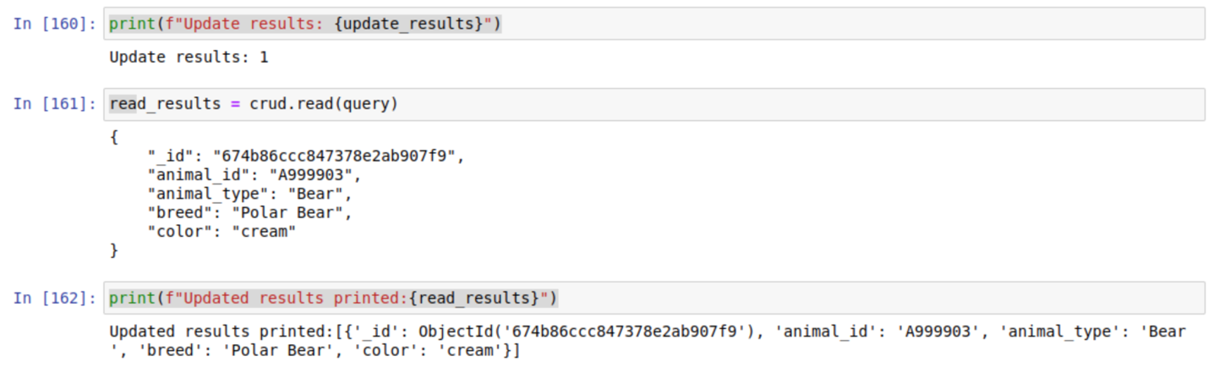

1. **Delete Functionality**

* **Filters documents based on the query (e.g., animal_id).**
* **Removes only the documents that match the criteria.**
* **Challenge: Ensuring correct deletion of intended documents.**
  + **Solution: Returned the count of deleted documents for verification.**

Delete a Document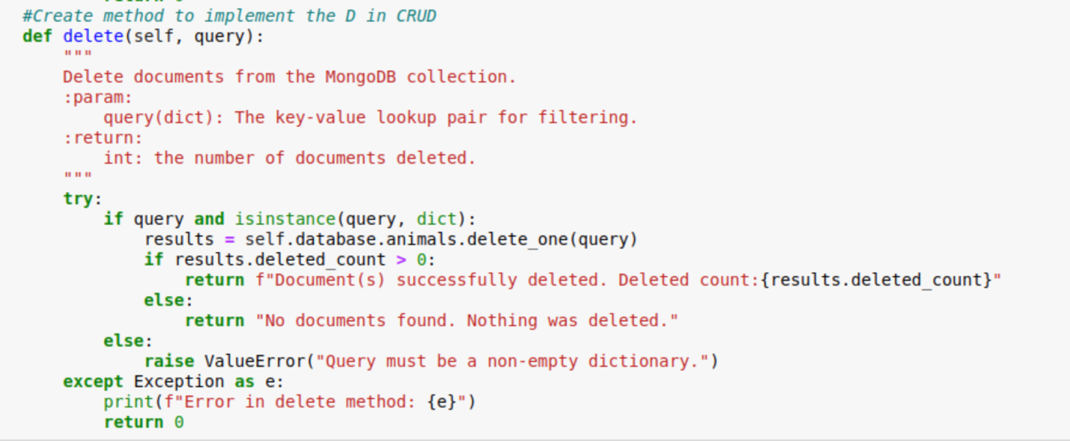

Output Screenshot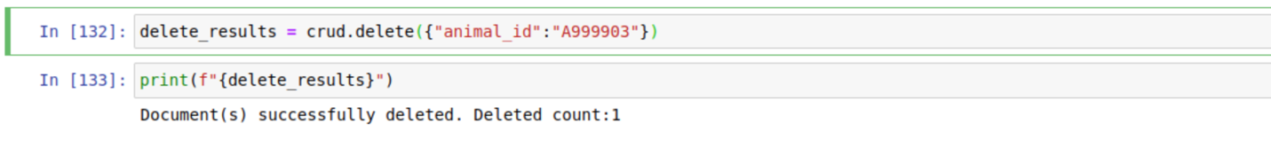

## MongoDB Data Modifications

### Rationale for Terminal-Based Updates:

To avoid saturating the Python code with additional complexity, rescue type modifications were handled directly in MongoDB through the terminal. This approach ensures the codebase remains modular and clean, focusing on CRUD operations without overburdening it with preprocessing logic. By leveraging MongoDB\u2019s flexibility, rescue types were efficiently updated using bulk commands, which also improved runtime performance by precomputing data.

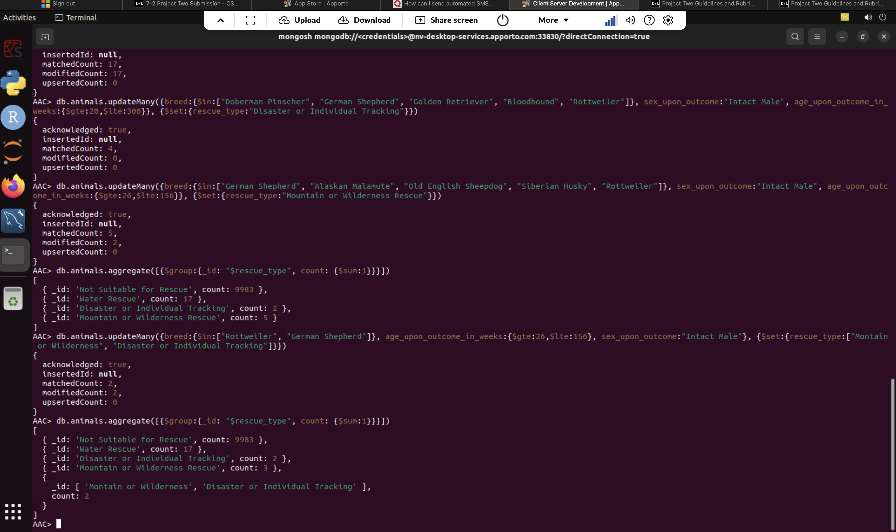

**Dashboard Implementation.**

**1. Importing Necessary Modules**

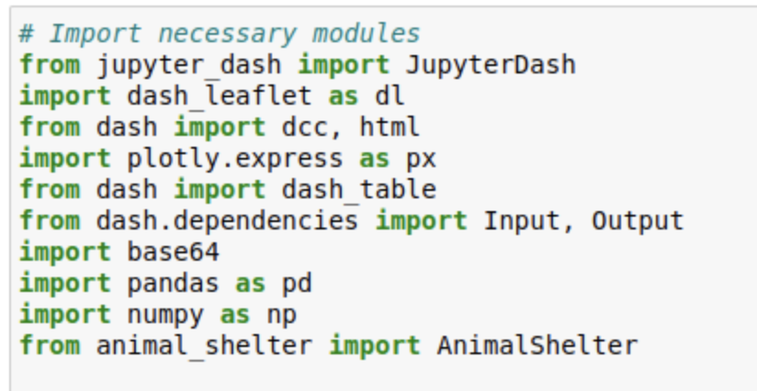

**Explanation:**

* **JupyterDash**: A variant of the Dash framework that lets you run Dash apps in Jupyter notebooks.
* **dash_leaflet**: Dash component library for rendering interactive maps using Leaflet.js.
* **dash, dcc, html**: Core libraries from Dash to create web-based interactive components (Dropdowns, Graphs, HTML layout elements).
* **plotly.express**: A high-level plotting library to quickly create charts such as pie charts, bar plots, etc.
* **dash_table**: Allows creation of interactive data tables.
* **dash.dependencies**: Used to declare callback inputs/outputs for responsive, data-driven interactions.
* **base64**: Used to encode images (like logos) as Base64 strings for embedding in the Dash app.
* **pandas, numpy**: Standard data manipulation libraries in Python.
* **animal_shelter**: Custom module containing the AnimalShelter class, which is presumably a wrapper to interface with a MongoDB database.

2. **Data Manipulation / Model**

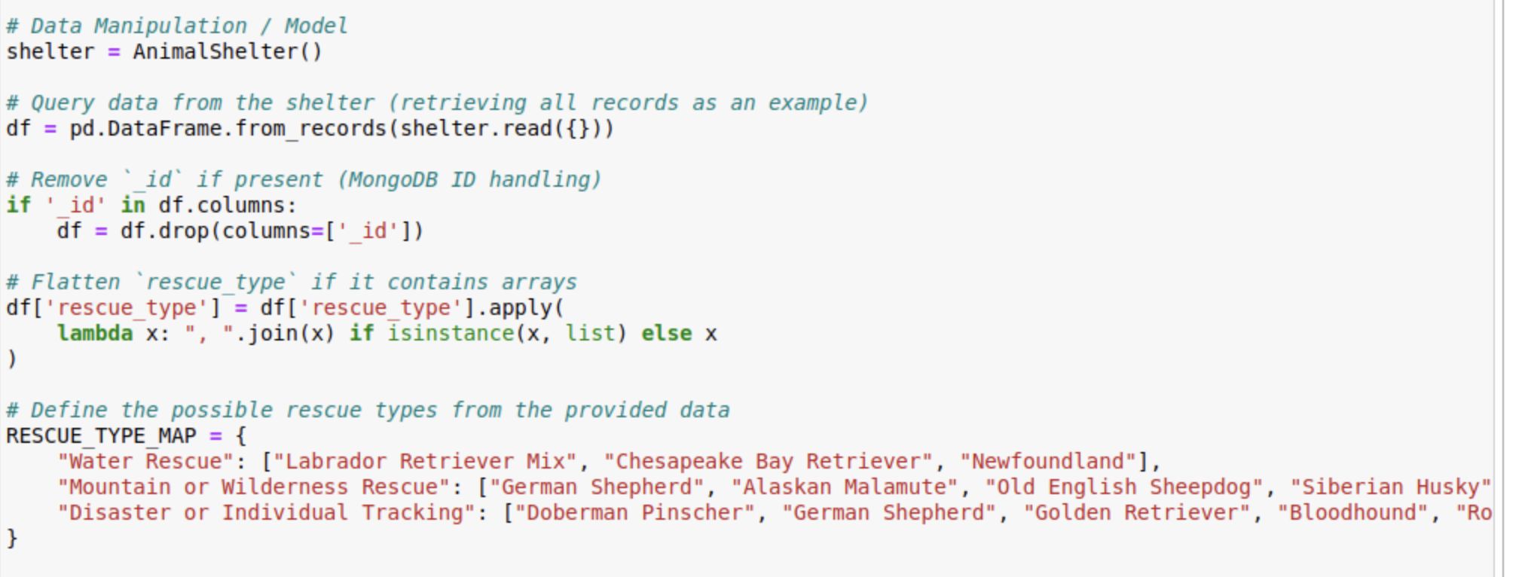**Explanation:**

1. **shelter = AnimalShelter()**  
   Initializes an instance of the AnimalShelter class to communicate with the MongoDB database.
2. **df = pd.DataFrame.from_records(shelter.read({}))**
   * Calls shelter.read({}) to query all records from the database and converts them into a pandas DataFrame.
3. **Removing _id column**
   * MongoDB documents typically have an _id field. The code drops it for cleanliness or to avoid serialization issues in Dash.
4. **Flattening rescue_type**
   * Some records may store rescue_type as a list. The lambda function joins list elements with commas if rescue_type is a list.
5. **RESCUE_TYPE_MAP**
   * A dictionary that categorizes certain breeds under specific rescue types. It helps in grouping the data or validating data entries.

3. **Creating the Dash App and Embedding a Logo**

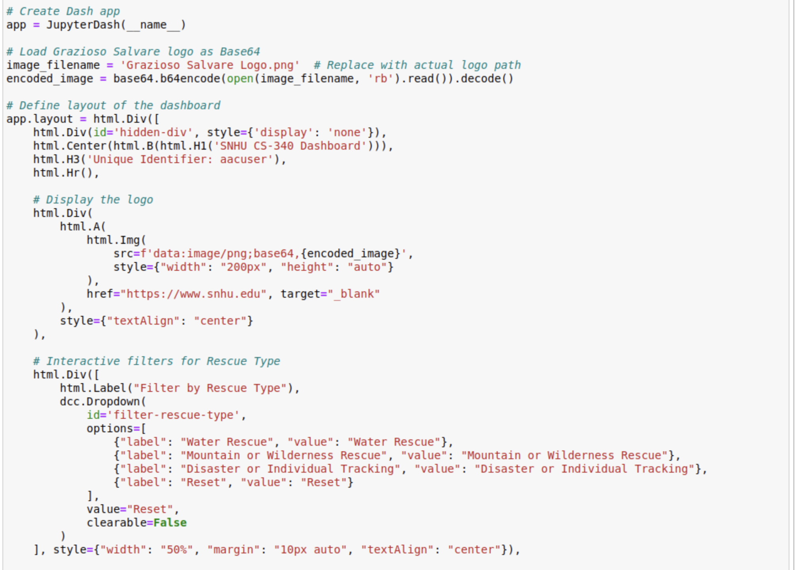**Explanation:**

1. **JupyterDash app initialization**
   * app = JupyterDash(__name__) sets up a Dash app that can be run in a Jupyter Notebook or standalone.
2. **Loading and embedding an image**
   * The logo (e.g., “Grazioso Salvare Logo.png”) is opened in binary mode, encoded in Base64, and stored in encoded_image.
   * The src attribute of html.Img is set to the Base64 string so the image can be displayed directly by the browser.
3. **App layout**
   * Uses Dash’s HTML components to build the page structure:
     + A hidden div used for possible storing of data or callback triggers.
     + A centered header with SNHU and user identifier.
     + A clickable logo linking to SNHU’s website.
     + A **Dropdown** (dcc.Dropdown) that lets the user filter data by rescue type.

4. **Creating a Data Table and Pie Chart**

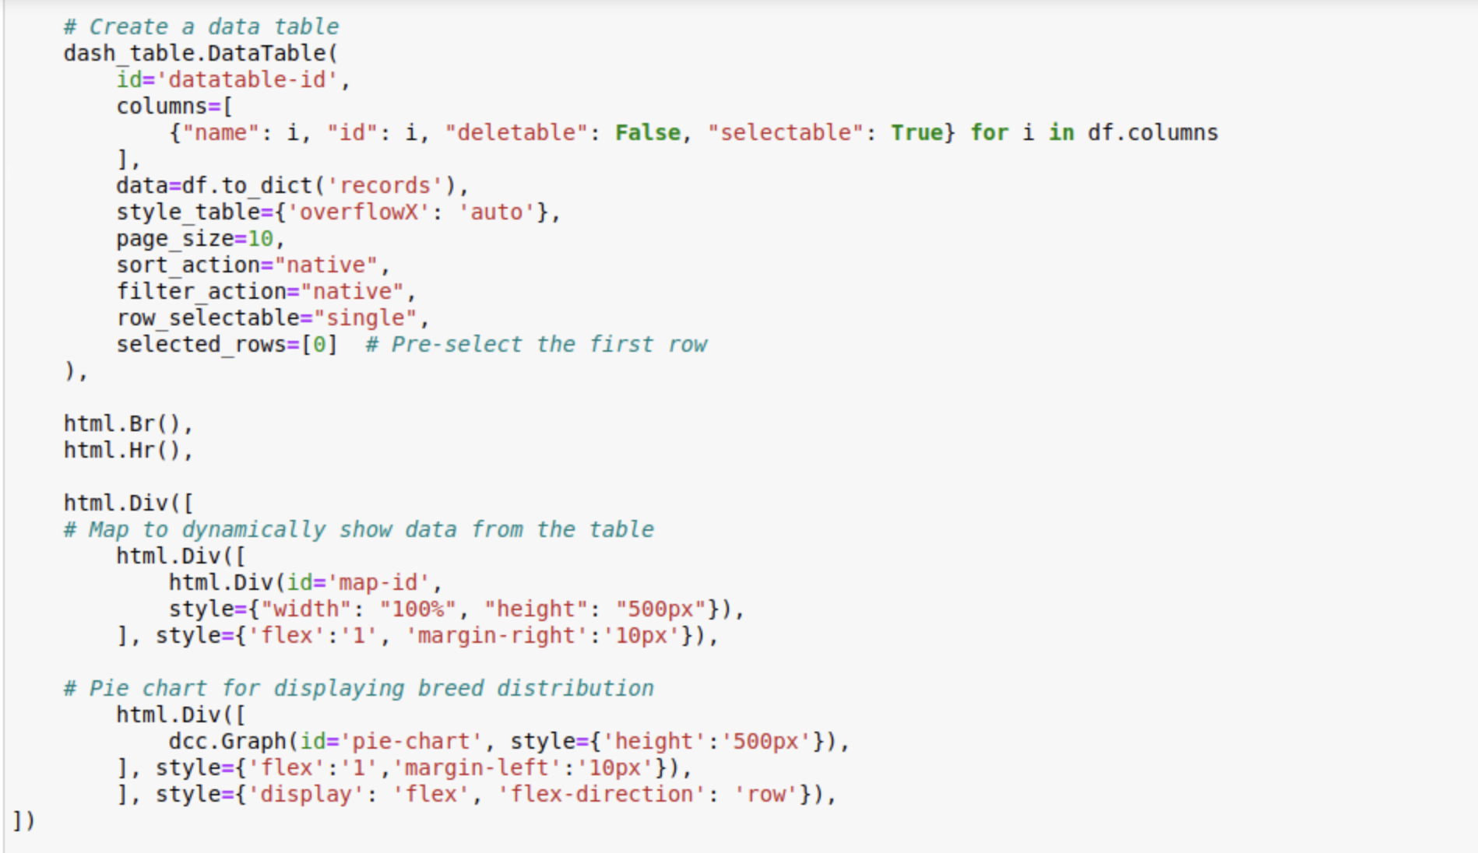**Explanation:**

1. **DataTable**
   * Displays the queried animal data in a tabular format.
   * columns are generated dynamically based on df.columns.
   * Each row is selectable (row_selectable='single'), so the user can click a row and see details elsewhere.
   * sort_action and filter_action both set to 'native', allowing sorting and filtering directly on the client side.
   * selected_rows=[0] automatically selects the first row upon page load.
2. **Layout for map and pie chart**
   * After the table, a Div labeled map-id is placed to hold the interactive Leaflet map.
   * Another Div contains a dcc.Graph for displaying a pie chart. Both are placed side by side using Flexbox styling.

5. **Callbacks for Filtering Data and Updating the Pie Chart**

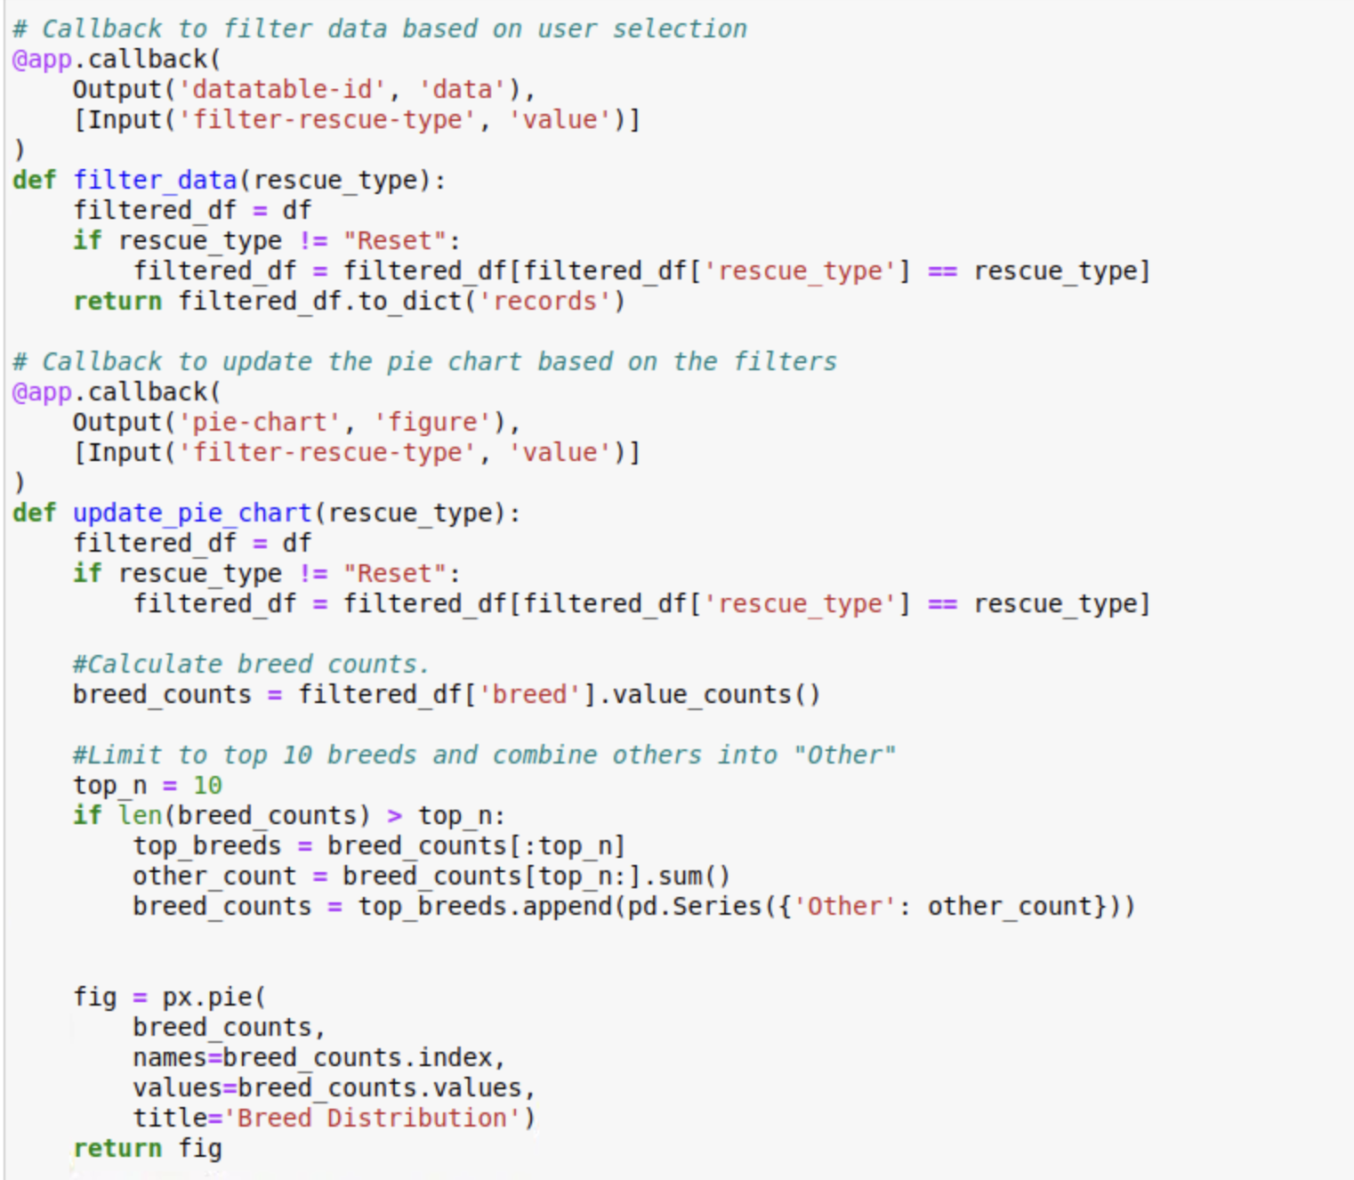**Explanation:**

1. **First callback** (filter_data):
   * **Triggered by**: The value of the dropdown filter-rescue-type.
   * **Output**: Updates the data property of the DataTable (datatable-id).
   * If the user chooses a specific rescue type (e.g., “Water Rescue”), it filters the DataFrame to show only rows matching that rescue type. If “Reset” is chosen, it shows all rows.
2. **Second callback** (update_pie_chart):
   * **Triggered by**: The same dropdown filter-rescue-type.
   * **Output**: Updates the figure of the pie chart (pie-chart).
   * Logic: Filter the DataFrame similarly. Then compute how many animals belong to each breed, limit to the top 10, combine any remaining breeds into an “Other” category, and finally create a pie chart with Plotly Express.

6. **Callback to Update the Map**

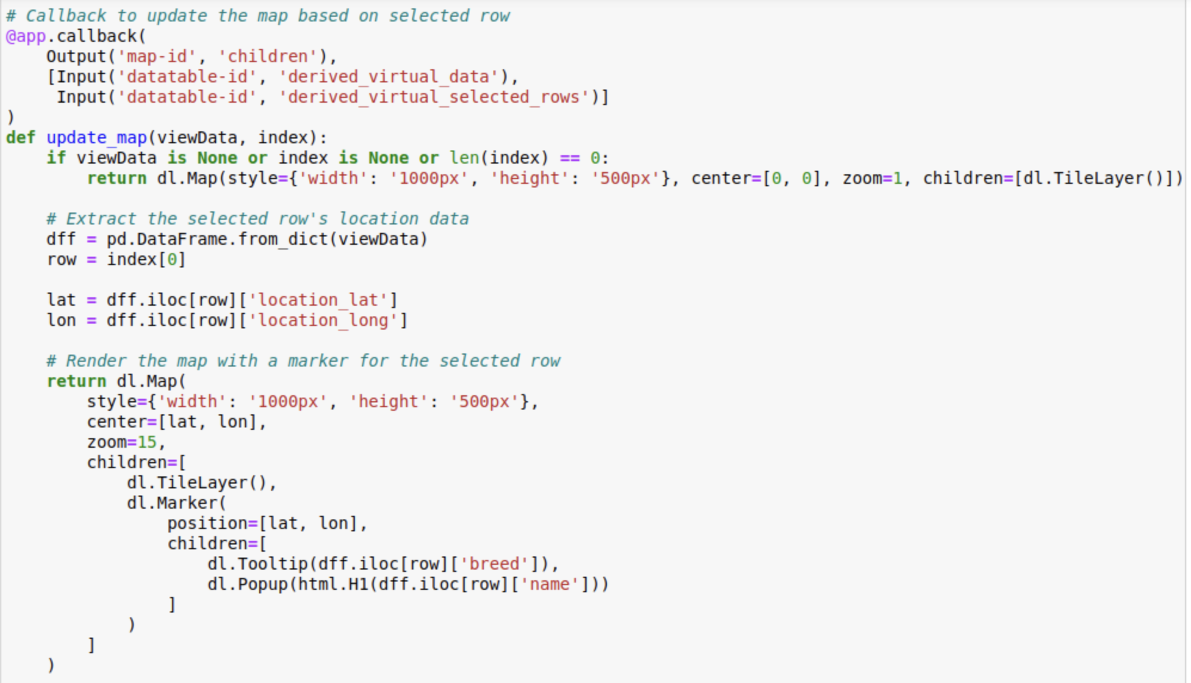**Explanation:**

* **Callback** is triggered whenever the data in the table changes or a different row is selected.
* Checks if any row is selected (derived_virtual_selected_rows). If nothing is selected, returns a default map centered at [0, 0] with zoom level 1.
* Otherwise, extracts the latitude (location_lat) and longitude (location_long) from the selected row and updates the map to center on that location.
* **dl.TileLayer()**: The base map layer from Leaflet.
* **dl.Marker()**: A pin dropped at the location. Contains a Tooltip (showing breed) and a Popup (showing the animal’s name).

7. **Running the Server**

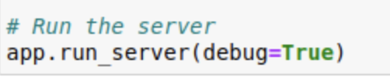

**Explanation:**

* **app.run_server(debug=True)** starts the local server in “debug” mode, providing detailed error messages and live reloading if changes are made to the code.
* Once running, you can view the dashboard by navigating to the provided local web address (usually http://127.0.0.1:8050 or similar).

Screenshots of the finished Dashboard:

